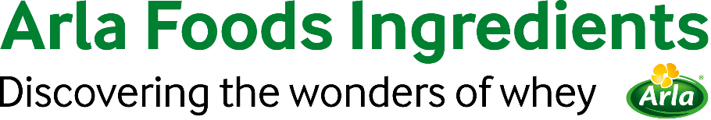

11th March 2022

PRESS RELEASE

Arla Foods Ingredients receives positive EFSA opinion
for Peptigen® IF-3080

The European Food Safety Authority (EFSA) has published an opinion that Arla Foods Ingredients’ Peptigen® IF-3080 (protein hydrolysate) is safe and suitable for use in infant formula and follow-on formula products in the EU.

The news follows EU regulations, which state that from February 22, 2022, the nutritional safety and suitability of all protein hydrolysates used in the manufacture of infant milk formula and follow-on formula in the EU would need to be evaluated. To date, Arla Foods Ingredients’ Peptigen® IF-3080 is one of only a few milk protein hydrolysate ingredients to receive a positive EFSA opinion. Those which are not approved are removed from the market.

The European Commission is expected to include Peptigen® IF-3080 in the Commission Delegated Regulation (EU) 2016/17 within the coming 12 months. Thereby, Arla Foods Ingredients’ Peptigen® IF-3080 will be approved for use in infant and follow-on formulas sold in the EU. Until then, Arla Foods Ingredients can supply Peptigen® IF-3080 to its EU customers for the development of infant formula brands, which can be prepared for launch.

Anders Steen Jørgensen, Head of SBU Pediatric, Arla Foods Ingredients, said: “We are delighted by this opinion, which supports our reputation for having the industry’s highest levels of quality, innovation and food safety.”

For more information contact:

Steve Harman, Ingredient Communications
Tel: +44 (0)7538 118079 | Email: Steve@ingredientcommunications.com

About Arla Foods Ingredients
Arla Foods Ingredients is a global leader in value-added whey solutions. We discover and deliver ingredients derived from whey, supporting the food industry with the development and efficient processing of more natural, functional and nutritious foods. We serve global markets within early life nutrition, medical nutrition, sports nutrition, health foods and other foods and beverage products.

Five reasons to choose us:
- We have R&D in our DNA
- We offer superior quality
- We are your trusted business partner
- We support sustainability
- We ensure security of supply

Arla Foods Ingredients is a 100% owned subsidiary of Arla Foods. Our head office is in Denmark.

LinkedIn
http://www.linkedin.com/company/arla-foods-ingredients

LinkedIn (Latin America)
https://www.linkedin.com/showcase/arla-foods-ingredients-latin-america/

LinkedIn (China)
https://www.linkedin.com/showcase/arla-foods-ingredients-china/

